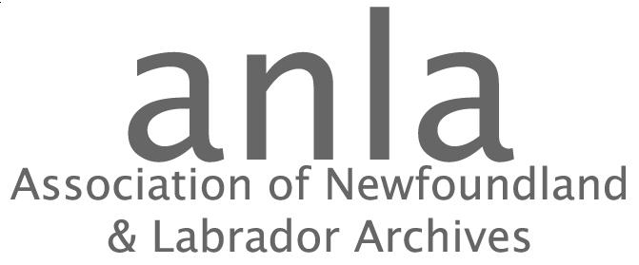

P.O. Box 23155, St. John's NL, A1B 4J9
Telephone: 709-726-2867 Fax:709-722-9035 E-mail: anla@nf.aibn.com

CALL FOR NOMINATIONS

The Association of Newfoundland and Labrador Archives is asking for nominations for the executive of our organization.

President
Vice-president
Secretary
Treasurer
3 Directors – ANLA directors represent members on the ANLA executive and attend monthly executive meetings in St. John’s (some travel assistance is available, or distance attendance can be arranged.).

Term of office is until the next AGM (June 2017).

Any member of the Association in good standing shall be eligible to hold office in the Association, with the exception of employees of the Association.

Nominations must be signed by the candidate, a nominator and a seconder, all of whom must be members in good standing. Elections will be held at ANLA ’s Annual General Meeting on May 27, 2015.

Nominations may be submitted to the ANLA office.

Deadline for nominations: May 17, 2016

NOMINATION FORM

I , _______________________________________________________, have accepted the nomination as a Director -at -Large of the Association of Newfoundland and Labrador Archives.

Nominee’s signature________________________________

Nominator________________________________________

Seconder_________________________________________

